DEALS TO LAKE PLACID

Lake Placid is a scenic village nestled among the Adirondack Mountains in upstate New York. Whether you’re headed there for a family vacation or a romantic getaway, Lake Placid is a beautiful place to visit, offering a ton of wonderful Adirondack attractions. Book a trip to Lake Placid via LaGuardia International, John F. Kennedy International Airport or Newark Liberty International Airport on Virgin America. Live it up at 35,000 feet with WiFi, on-demand entertainment, and more on every flight.

(MARKET IMAGE HERE)

Find Deals From These Cities

INSERT FARE GRID FROM / TO Version (if available!)

   
Top Things To Do in Lake Placid

With so many things to do in Lake Placid, you’ll want to hit some of these top activities on your list when you visit.

* Enjoy the beauty of your surroundings while relaxing in an Adirondack chair or having a picnic alongside the picturesque Mirror Lake.
* Take a thrilling bobsled ride down more than a half-mile of winding track at the Lake Placid Olympic Sports Complex. Depending on when you visit, you may even be able to watch Olympic athletes train.
* Visiting in the winter months? Ski & snowboard Whiteface Mountain, featuring diverse terrain over 283 acres.
* See the magnificent Adirondacks by train when you ride the Adirondack Scenic

Railway.

* If you find yourself in Chelsea, take a walk on the High Line. This old elevated train line has been turned into a beautiful linear park.

Travel Tips and Resources

[Must-Dos in Lake Placid](http://www.lakeplacid.com/)

[Lake Placid Hotels](http://www.tripadvisor.com/Hotels-g48023-Lake_Placid_New_York-Hotels.html)

[Lake Placid Restaurants](http://www.newyorkupstate.com/lake-placid/2015/04/best_places_to_eat_in_lake_placid.html)

[Lake Placid Shopping Guidehttp://www.lakeplacid.com/do/shop](http://www.lakeplacid.com/do/shop)

[Lake Placid Nightlife and Entertainmenthttp://www.lakeplacid.com/do/dining/bars-nightclubs](http://www.lakeplacid.com/do/dining/bars-nightclubs)

[Lake Placid Travel Tipshttp://traveltips.usatoday.com/things-pack-going-lake-placid-new-york-103617.html](http://traveltips.usatoday.com/things-pack-going-lake-placid-new-york-103617.html)

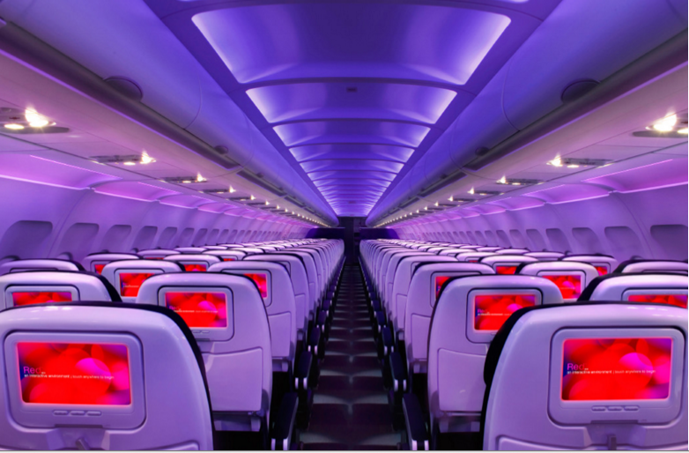

Main Cabin Main Cabin Select First Class

(add links to Cabin Class Pages)

Ready. Set. Fly.

Book your Mood-lit Ride to Lake Placid.

Looking for flights to Lake Placid? You’ll find that many people fly into New York City and take the approximately 4 ½ hour drive to Lake Placid to experience the beautiful landscapes and scenery through the Adirondacks. When planning your trip, book your flight to LaGuardia International, John F. Kennedy International Airport or Newark Liberty International Airport with Virgin America so you can have a relaxing and enjoyable flight. From our mood-lit cabins and ultra comfortable leather seats, to our on-demand WiFi and food ordering, you’ll find that flying with us is always a great experience.

Take a Virtual Tour

Add Terms & Conditions